Practical 10

Problem Definition

You are developing a data processing engine. Use an iterator to generate

an infinite number sequence and a generator to produce even numbers.

Code

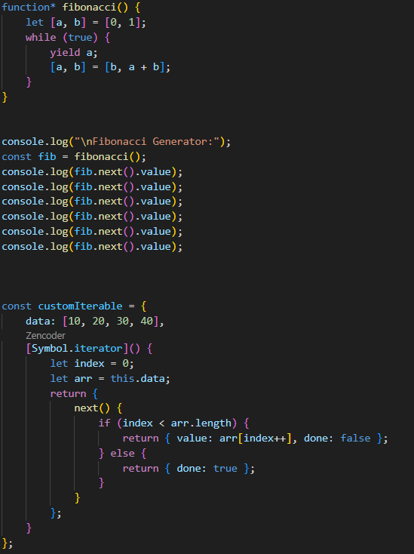

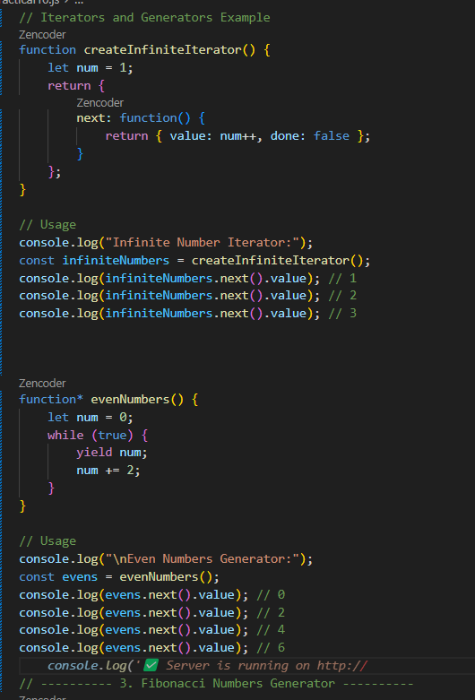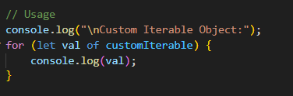

Output: 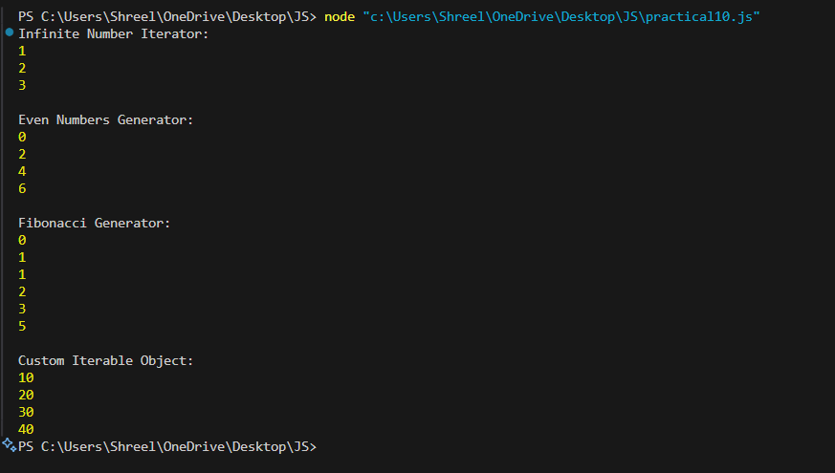

Practical 11

Problem Definition

Create a simulation for API data retrieval using callback functions to

display the data once retrieved.

Code: 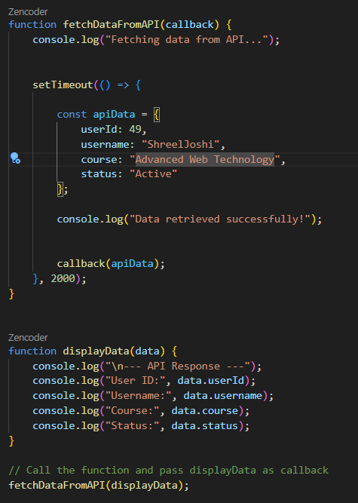

Output:

